**CONTENTS**

**Sl.No. List Of Topics Page Number**

1. Project Introduction

2. About Hotel Management System

3. Objectives and Scope of the Project

4. Language Outlook

5. System Specification

6. Problem Definition and description

7. System Analysis

8. Feasibility Study

9. Data Flow Diagram

10. Normalization

11. E-R Diagram

12. Course of Action & Compilation

13. Database Design

14. System Testing

15. Implementation

16. Conclusion

17. Screenshot

18. Bibliography’s

**OUTLINE**

Travel and tourism is a booming industry today. Technology has connected cities and destinations across different countries and bought them closer. The number of people travelling across different places has increased. Now, whether on a business trip or vacationing with family, everybody needs a place to stay and unwind. But it can be a pain in the neck sometimes getting the budget and then getting bookings done.

Online Hotel Reservation are becoming popular method for booking hotel rooms from how via their home computer using online security to protect their privacy and financial information and by using several online travel agents to compare prices and facilities at different hotels.

Prior to the internet, travelers could write, telephone the hotel directly or use a travel agent to make a reservation.

Now a day’s online travel agents have pictures of hotels and rooms, information on prices and deals, and even information on local resorts. Many also allow reviews of the travelers to be recorded with the online travel agent.

Online reservations are also helpful for making last minute travel arrangements. Hotels may drop the price of a room if some rooms are still available. There are several website s that specialize in searches for deals on rooms. Large hotel chains typically have direct connections to the airline national distribution System.

In this **Hotel Management System** is an establishment that provides paid lodging, usually on a short term basis. The provision of basic accommodation, in times past, consisting only of a room with a bed, a coupboard,a small table and a wash stand has largely been replaced by rooms with modern facilities ,including en-suite bathrooms and air conditioning or climate control.

Although technology is rapidly changing almost at the speed of light. Some hotels are still using manual reservation system to check In/Out customers rooms are done manually hence providing:

* Providing untimely assement information’s.
* Consumes a lot of time.
* Waste and use lots of resource such as forms.

The sub-objective are to identify the requirements and design the hotel management system that will resolve the above problem of manual reservation system by designing and implementing the proposed system successfully it will benefit many parties ,firstly by providing staff with access of easy view form.

**MOTIVE OF HOTEL MANAGEMENT SYSTEM**

The motive of our project is to control various activities performed. In the Hotel using the computer with the work of **HOTEL MANAGEMENT SYSTEM**.

From the beginning, the important thing in our mind is that we should concentrate our project work on a subject that is easy to understand and is according to our daily requirement.

By keeping this in mind, the subject chosen by us is **HOTEL MANAGEMENT**.

In the present time there is a great rush in hotels, as these have become necessity for middle and upper class of the society. People travel a lot, stay in the hotels, goes to the hotels for functions, meetings and refereshment.Our project is developed keeping of the customers when she/he goes to the hotels.

An important uniqueness about the described hotels, restaurants and bar are available to only those customers who have already booked room or hall in the hotel.

The Hotel Management is an automated version of manual hotel management system. It can handle all details about a customer. The details include customer’s details, His/her personnel details, room details, booking details etc.

In case of manual system they need a lot of time, manpower etc.

Here almost all work is computerized .So; the accuracy is maintained .Maintaining backup is very easy. It can do within a few minutes. Our system has 2 types of accessing modes: Administrators and the user.

HOTEL MANAGEMENT SYSTEM is managed by a manager. It is the job of the administrator to insert, update and monitor the whole process. When a user log in to the system she/he can’t perform any changes.

**OBJECTIVE OF THE PROJECT**

1. The main Objective of this system is to conduct a simple and systematic computerized of **“HOTEL MANAGEMENT SYSTEM”**
2. To generate instant report by saving manpower and valuable time.
3. To make the system “User Friendly” so that the lower level users does not have any troubles while entering the detail information.
4. It should contain all the information of hotel employees.
5. It should contain all the information of hotel infrastructure or campus.
6. It should provide every detail about the hotel and making sure that the staff are getting paid and well cared.
7. Hotel management not only dealing with the food of guest they also offer lodging accommodation.
8. Hotel Management is the overall managing and handling of all departments in the hotels.

**PURPOSE OF THE PROJECT**

Computerized **HOTEL MANAGEMENT SYSTEM** is developed to facilitate the general administration system to manage the various information of the customers and the processes involved in a hotel. So, that the hotel can access accurate information quickly and easily as and when required thereby improving its operational efficiency and effectiveness.

**SCOPE OF THE PROJECT**

The scope of the **Hotel Management** is that to maintain a computerized database so that at any point of time the customers can get the up-to-date information very quickly and easily.

1. **Customers’ Registration:** In this module all the personal details of the customers is to be recorded such as full name, Gender, Address, Phone Number, Booking date, Time, etc.
2. **Room booking:** In this module the customer will book their room from their home via their computer.
3. **Vehicle booking:** Customers book vehicles for roaming their favorite place and to see their desired spots.
4. **Online payment:** customer pays their payment through their credit card, debit card from a single swipe.

**LANGUAGE OUTLOOK**

Java is a programming language originally developed by James Gosling at Sun Microsystems (which has since merged into Oracle Corporation) and release in 1995 as a core component of sun Microsystems’ java platform. The language derives much of its system from C and C++ but has a simpler object model and fewer low – level facilities. Java applications are typically compiled to byte code (class file) that can run on any Java Virtual Machine (JVM) regardless of computer architecture.

Java is a general purpose, concurrent, class-based, object –oriented

Languages that is specifically designed to have as few implementation dependencies as possible. It is intended to let application developers “write once, run anywhere” (WORA), meaning that the code that runs on one platform does not need to be recompiled to run on another. Java is currently one of the most popular programming languages in use, particularly for client- server web applications, with a reported 10 million users.

**FEATURES OF JAVA**

* **Platform Independent:** The concept of write-once-run-anywhere (known as the platform independent) is one of the important key feature of java language that makes java as the most powerful language. Not even a single language is idle to this feature but java is closer to this feature. The programs written in one platform can run on any platform provided the platform must have the JVM.
* **Simple:** There are various features that make the java as a simple language. Programs are easy to write and debug because java does not use the pointer explicitly. It is much harder to write the java programs that can crash the system but we cannot say about the other programming languages. Java provides the bug free system due to the strong memory management. It also has the automatic memory allocation and de allocation system.
* **Object oriented:** To be object oriented language, any language must follow at least the four characteristics.
* **Inheritance:** It is the process of creating the new classes and using the behavior of the existing classes by extending them just to reuse the existing code and adding the additional features as needed.
* **Encapsulation:** It is the mechanism of combining the information and providing the abstraction.
* **Polymorphism:**  As the name suggests one name, multiple forms, polymorphism is the way of providing the different functionality by the functions having the same name based on the signatures of the method.
* **Dynamic binding:** Sometimes we don’t have the knowledge of objects about their specific types while writing our codes. It is the way of providing the maximum functionality to a program about the specific type at runtime.

As the languages like Objective C, C++ fulfills the above four characteristics yet they are not fully object oriented languages because they are structured as well as object oriented languages. But in case of java, it is fully object oriented language because object is at the outer most level of data structure in java. No standalone methods, constant and variables are there in java. Everything in java is object even the primitive data types can also be converted into object by using the wrapper class.

* **Robust:** Java has the strong memory allocation and automatic garbage collection mechanism. It provides the powerful exception handling and type checking mechanism as compare to other programming languages. Compiler checks the programs whether any run time error and makes the system secure from crash. All the above features make the java language robust.
* **Distributed:** The widely used protocols like HTTP and FTP developed in java.Interent programmers can call functions on these protocols and can get access the files from any remote machine on the internet rather than writing codes on their local system.
* **Portable:** The feature Write-once-run- anywhere makes the java language portable provided that the system must have interpreter for the JVM.Java also has the standard data size irrespective of operating system or the processor. These features make the java as s portable language.
* **Dynamic:** While executing the java program the user can get the required files dynamically from a local drive or from a computer thousands of miles away from the user just by connecting with the Internet.
* **Secure:** java does not use memory pointers explicitly. All the programs in java are run under an area known as the sand box. Security managers determine the accessibility options of a class like reading and writing a file to the local disk. Java uses the public key encryption system to allow the java applications to transmit over the internet in the secure encrypted form. The byte code verifier checks the classes after loading.
* **Performance:** java uses the native code usage, and light weight process called threads.

In the beginning interpretation of byte code resulted the performance slow but the advance version of JVM uses the adaptive and just in time compilation technique that improve the performance.

* **Multithreaded:** As we all know several features of Java like Secure, Robust, Portable, Dynamic etc; you will be more delighted to know another feature of Java which is **multithreaded.** Java is also a multithreaded programming language.

Multithreading means a single program having different threads executing independently at the same time. Multiple threads execute instructions according to the program code in a process or a program. Multithreading works the similar way as multiple processes run on one computer.

Multithreading programming is very interesting concept in java. In multithreaded programs not even a single thread disturbs the execution of other thread. Threads are obtained from the pool of available ready to run threads and they run on the system CPUs.

This is how Multithreading works in java which you will soon come to know in details in later chapters.

* **Interpreted:** We all know that java is an interpreted language as well. With an interpreted language such as java, programs run directly from the source code.

The interpreter program reads the source code and translates it on the fly into computations. Thus, Java as an interpreted language depends on an interpreter program.

The veracity of being **platform independent** makes a java to outshine from other languages. The source code to be written and distributed is platform independent.

Another advantage of java as an interpreted language is its error debugging quality. Due to this any error occurring the program gets traced. This is how it is different to work with java.

* **Architecture:** The term architectural neural seems to be wired, but yes java is an architectural neutral language as well.

The growing popularity of networks makes developers think distributed. In the world of network it is essential that the application must be able to migrate easily to architecture and operating systems.

Not only to computer system but to a wide variety of hardware architecture and operating system architecture as well. The java compiler does this by generating byte code instructions, to be easily interpreted on any machine and to be easily translated into native machine code on the fly.

The compiler generates an architecture-neutral object file format to enable a java application to execute anywhere on the networks and then the compile code is executed on many processors, the given presence of the java runtime system.

Hence java was designed to support applications on network. This feature of Java has thrived the programming language.

**JAVA SERVLET**

Java servlet technology provides web developers with a simple, consistent mechanism for extending the functionality of a web server and for accessing existing business systems. Servlet are server side Java EE components that generate responses (typically HTML pages) to request (typically HTTP request) from clients. A servlet can almost be thought of as an applet that runs on the server side without a face.

//Hello.java

Import java.io.*;

Import javax.servlet.*;

Public class hello extends GenericServlet

{

Public void service (final servletRequest, final ServletResponse response)

Throws ServletException, IOException

{

Response.setCounterType (“text/html”);

Final PrintWriter pw=response.getWriter ();

Try {

Pw.println (“Hello, world”);

} finally {

Pw.close ();

}

}

}

The **import** statements direct the java compiler o include all the public classes and interfaces from the **java.io** and **javax.servlet** packages in the compilation.

The **Hello** class **extends** the **GenericServlet** class; the GenericServlet class provides the interface for the server to forward requests to the servlet and control the servlet’s life cycle.

The Hello class overrides the service (ServletRequest, ServletResponse) method defines by the servlet interface to provide the code for the service request handler. The service () method is passed a ServletRequest object that contain the request from the client and the ServletResponse object used to create the response returned to the client. The service () method declares that it throws the exceptions ServletException and IOException if a problem prevents it from responding to the request.

The setContentType (String) method in the response object is called to set the MIME content type of the returned data to “text/html”.The get Writer()method in the response returns a PrintWriterobject that is used to write the data that is sent to the client. The println (String) method is called to write the “Hello, world!”String to the response and then the close () method is called to close the print writer, which causes the data that has been written to the stream to be returned to the client.

**JAVA SERVER PAGE (JSP):**

The Sun Microsystems’s java server pages technology allows us to rapidly develop and easily maintain rich, dynamic web pages. As a part of java family JSP enables development of web based applications that are platform independent. The web applications build using JSP technology works with a wide variety of web servers, application servers, browsers and development tools. The logic that generates the content is encapsulated in tags and JavaBeans components and tied together in scriplets, all of which are executed on the server side. If the core logic is encapsulated in tags and Beans then other individuals, such as web masters and page designers, can edit and work with JSP pages without effecting the generation of the content.Thuis the JSP technology separates the user interface from the content generation.JSP page is simply an HTML web page, which contain additional bits of code that generate dynamic content of the page’s technology is a part of java family. It uses a java programming language based scripting language and JSP are compiled into java servlet the first time they are invoked.Jsp pages may call JavaBeans,EJB components,RMI objects,DBC objects to perform processing on the server. Example JSP page may contain HTML that display static text and graphic as well as a method call to JDBC object that access database, when the page is displayed in a user’s browser.

**FEATURES OF JSP:**

* JSP technology follows the write once run anywhere rule which is the basis of the java language.
* JSP use pure java and takes the advantage of its object oriented nature.
* JSP uses a combination of tags and scripting to create dynamic web pages.
* The JSP page uses the components like EJB, Java beans which are reusable. This gives the JSP reusability capabilities.
* Applications made using JSP technology are easier to maintain.

**SYSTEM SPCIFICATION:**

**Tools/ platform**

The **“Hotel Management System”** is basically **is** used in Educational organization. Tools to be used: Java Server Pages (JSP).

**ENVIRONMENTAL:**

**Hardware and software requirements:**

* The system must be user friendly
* The system must be able to handle large volume of data.
* Processing speed of the speed of the system should be huge.

**Hardware specification:**

The software has been developed on computers with the following specifications.

**The Client Machines:**

* Processor : Intel processor IV
* Speed: 3.2GHz
* RAM: 3GB
* Hard disk: 80GB
* Key Board(104 keys): Standard
* Printer: Dot Matrix, Laser Printer

**Software Specification:**

* Operating System: Windows XP
* Language: JSP/SERVLET
* Tools: Dreamweaver 4.0/Tomcat

**PROBLEM DEFINATION AND DESCRIPTION:**

**Existing System –**

The existing is a manual system. The main tasks of the existing system are to accept their requirements from different areas in India and verify them and process. The need for computerization of existing system arose because of many difficulties regularities and inaccuracy present in the current system. The main causes of worry include lack some important information in rerecords and reports in accuracies in certain transactions in various time consuming activities. For Example: the staff often found it difficult to keep track of suspense field numbers such as different areas did having the same amount. They fail to show proper head combinations in different reports which result in lack of some vital information in the reports. For an example of inaccuracy, reports are sometimes incorrectly mades.Generating some reports especially the monthly reports are very time consuming task.

Preparing correct report is a cumbersome process as it involves a lot of different calculations basing on different rules. Also copy of same record is made many times in different format. Most of the time the staff fails to represents the correct calculations creating controversial and pending cases. The process is a time consuming process resulting in late delivery of account slip.

The existing system was having a number of difficulties regarding maintaining the record of information, records of their booking in the hotel.

1. First of all our focus will be on the manual system for hotel management. One can observe that for the whole process of all the record of information, records of their bookings in the hotel and it tell us about the booking and checking out of the customer, their room type etc.
2. Second is the efficiency, time elapsed and the human error involved.
3. Finally beside these the most important is the data storage, searching for a particular record, transferring the data into various networks and data piracy.

**Proposed system with objectives –**

The proposed system is the panacea of above mentioned problems. By using this system an organization can handle its all kinds of above mentioned works efficiently, accurately and swiftly with all kinds of security features by involving a few employees.

**Advantages of the proposed system –**

1. Manpower can concentrate on mainstream jobs and machines can do repetitive natures of jobs.
2. Introduction of self-checking mechanies can reduce errors and prevent ignorant or intentional irregularities.
3. Computerization in network fashion will provide an integrated MIS to all the departments and help to formulate realistic budgets.
4. Systematic storage and retrieval of large amount of data.
5. Capturing from the bill scan develop allied MIS.
6. Decision makers can decide budgetary requirements and allocations.
7. Expenses can be streamlined by knowing the ways and means position.
8. Internal auditing and control can be carried out.

**Benefits of the computerized system –**

Have various facilities. Few of them are:

1. It is easy to use and faster than manual system.
2. Tasks are achieved in simple and efficient manner.
3. It is easy to get information about customers through their booking.
4. Fast access to all the information.
5. Timely and accurate information is provided.
6. The whole authority is given to the administrator.
7. It is easy and beneficial for generating the report.
8. Tool tip properties are added in all the components of the system.
9. Error handling at the time of inserting the data retrieving the data and modifying the data from data base.
10. You can generate whole information of particular customers.
11. Update password facilities are included.
12. To give permission to only authorized person for the data entry.
13. Saving main power, paper work, time, etc.

**SYSTEM ANALYSIS:**

Analysis is the focus of system developing and is the stage when system designers have to work at two levels of definition regarding the study of situational issues and possible solutions in terms of “what to do” and “how to do”.

The primary goal of the system analyst is to improve the efficiency of the existing system. For the development of the new system, a preliminary survey of the existing system will be conducted.

Investigation done whether the up gradation of the system into an application program program could solve the problems and eradicate the inefficiency of the existing system.

**System study**

**Definition of the system**

A system is an orderly grouping of independent components linked together according to a plan to achieve a specific objective. Its main characteristics are organization, interaction, independent, integration and central objective a system does not necessarily mean to a computer system. It may be a manual system or any other name.

**Needs of the system**

1. Social and economic factor: A wave of social and economic changes often follows in the wake of the new technology. New opportunities may arise to improve on a production process or to do something that was not previously possible. Changes in the way individuals are organized into groups may then be necessary, and the new groups may complete for economic resources with established units.
2. Technological factors: People have never before in a time when a scope of specific inquiry was a board, so when the speed of applying the new technology accounts for many changes in the organization.
3. High-level decisions and operating processes: in response to technological, socio-economical factors, top level managers may decide to recognize operations and introduce new products.

To deal with these needs, people commonly seek new modified information to support the decision.

When that happens, then they obtain turn to a computer system for help to the information users and data processing specialist then work together to complete a series of steps in a system study to produce output results to satisfy information needs.

**System Analysis**

System Analysis is a process by which the attribute process or goals to a Human activity, determine how well those purpose are being achieved and specify the requirements of the various tools and techniques that are to be used within the system if the system performances are to be achieved.

**System Planning**

Planning for information system has a time horizon and a focus dimension. The time horizon dimension specifies the time range of the plan, where as the focus dimension relates whether the primary concerns in strategic, managerial or operational .The system i.e. The project that we were assigned was required to complete within 20 weeks. What we had planned is as follows:

Requirement analysis, Preliminary investigation and information gathering should be covered within the 1st and 2nd week. Since we were not aware of some of the tools i.e.JSP, File system, we had kept 3e weeks to understand the knots and bolts of these tools.6 weeks for the design of the system under development.1 week for testing and implementation. And rest 2 reserve weeks.

**Preliminary Investigation**

The initial investigation has the objective of determining the validity of the users request for a candidate system and whether a feasibility study should be conducted.

The objective of the problem posed by the user must be understood within the framework of the organization’s MIS plan. We had investigated from the concerned authority about the project.

**Information Gathering**

A key part of feasibility analysis is gathering information about the present system. The analyst must know what information to gather, where to find it, how to collect it, and what to make of it. The proper use of tools for gathering information is the key to successful analysis. The tools are the traditional interview, questionnaires and on-side observation.

**FEASIBILITY STUDY**

The initial investigation points to the question whether the project is feasible. Feasibility is conducted to identify the best system that meets all the requirements. This includes an identification description, a valuation of the proposed systems and selection of the best system for the job. The requirements of the system are specified with a set of constraints such as system objectives and the description of the outputs. It is then the duty of the analyst to evaluate the feasibility of the proposed system to generate the above results. Three key factors are to be considered during the feasibility study.

**Operation Feasibility**

An estimate should be made to determine how much effort and care will go into the developing of the system including the training to be given to the user. Usually, people are reluctant to changes that come in their progression. The computer initialization will certainly affected the turn over, transfer and employee job status. Hence an additional effort is to be made to train and educate the users on the new way of the system.

**Technical Feasibility**

The main consideration is to be given to the study of available resource of the organization where the software is to be implemented. Here the system analyst evaluates the technical merits of the system giving emphasis on the performance, Reliability, Maintainability and productivity.

By taking the consideration before developing the proposed system, the resources availability of the organization was studied. The organization was immense computer facilities supplied with sophisticated machines and the software hence this technically feasible.

**Economic Feasibility**

Economic feasibility is the most important and frequently used method for evaluating the effectiveness of the proposed system. It is very essential because the main goal of the proposed system is to have economically better result along with increased efficiency. Cost benefit analysis is usually performed for this purpose. It is the comparative study of the cost verses the benefit and savings that are expected from the proposed system. Since the organization is well equipped with the required hardware, the project was found to be economically.

**Information Gathering**

A key part of feasibility analysis is gathering information about the present system. The analyst must know what information to gather, where to find it, how to collect it, and what to make of it. The proper use of tools for gathering information is the key to successful analysis. The tools are the traditional interview, questionnaires and on-site observation.

**Structured Analysis**

The traditional tools of data gathering have limitations. An English narrative description is often vague and difficult for the user to grasp.

System flowchart focus more on physical then on logical implementation of the candidate system. Because of these drawbacks, structured tools were introduced for analysis.

Structured analysis is a set of techniques and graphical tools (DFD) that allow the analyst to develop a new kind of system specification that are easily understandable to the user.

**DATA FLOW DIAGRAM**

Data flow diagram is a diagrammatic representation of data movement through a system- manual or automated – from inputs to outputs through processing. The data flow diagrams help in the analysis of the flow of data through a system and thus the help in identifying the system requirements.

These are the two types - Logical data Flow Diagrams and Physical data Flow Diagrams.

The data Flow Diagram (DFD) clarifies system requirements and identifies major transformations that will become programs in system design.

It is the starting point of system design that decomposes the requirements specifications down to the lowest level of detail.

**Local Data Flow Diagrams**

The Logical Data Flow Diagrams represent the transformation of the data from input to output through processing logically and independently of the physical components that may be associated with the system.

**Physical Data Flow Diagram**

The physical data Flow Diagrams show the actual implementation and movement of data between people, departments, and workstations.

Each components of a DFD is labeled with a descriptive name. Process names are further numbered that will be used for identification purposes.

The number assigned to a specific process does not correspond to the sequence of process. It is strictly for assigned to a specific process does not correspond to the sequence of processes.

It is strictly for identification purposes. A Data Flow Diagram allows parallel activities i.e. a number of data-flows coming out from the source and going into the destination.

A DFD concentrates on the data moving through the system and not on the devices or equipments’ DFD may consist of a number of levels.

The top-level diagram is called the Context Diagram, which consist of a single process and plays a very important role in studying the system.

It gives the most general and broadest view of the system.

Move over it gives the pictorial representation of the scope boundaries of the system under study.

**Notations**

Data-Flows show the movement of data in a specific direction from the source to the destination. It represents a packet of data.

Process shows operations performed on the data, which transforms it from input to output.

Sources and Destinations of data are the external sources and destinations of data, which may be people, programs, organizations or other entities interacting with the system, but are outside its boundary.

Data stores are places where data are stored such as files and tables.

Below is the Top level DFD showing how the User’s request processed by the server with database interaction and sends the response back to the user.

**LEVEL 0 (HOTEL MANAGEMENT SYSTEM)**



**LEVEL 1 DFD**

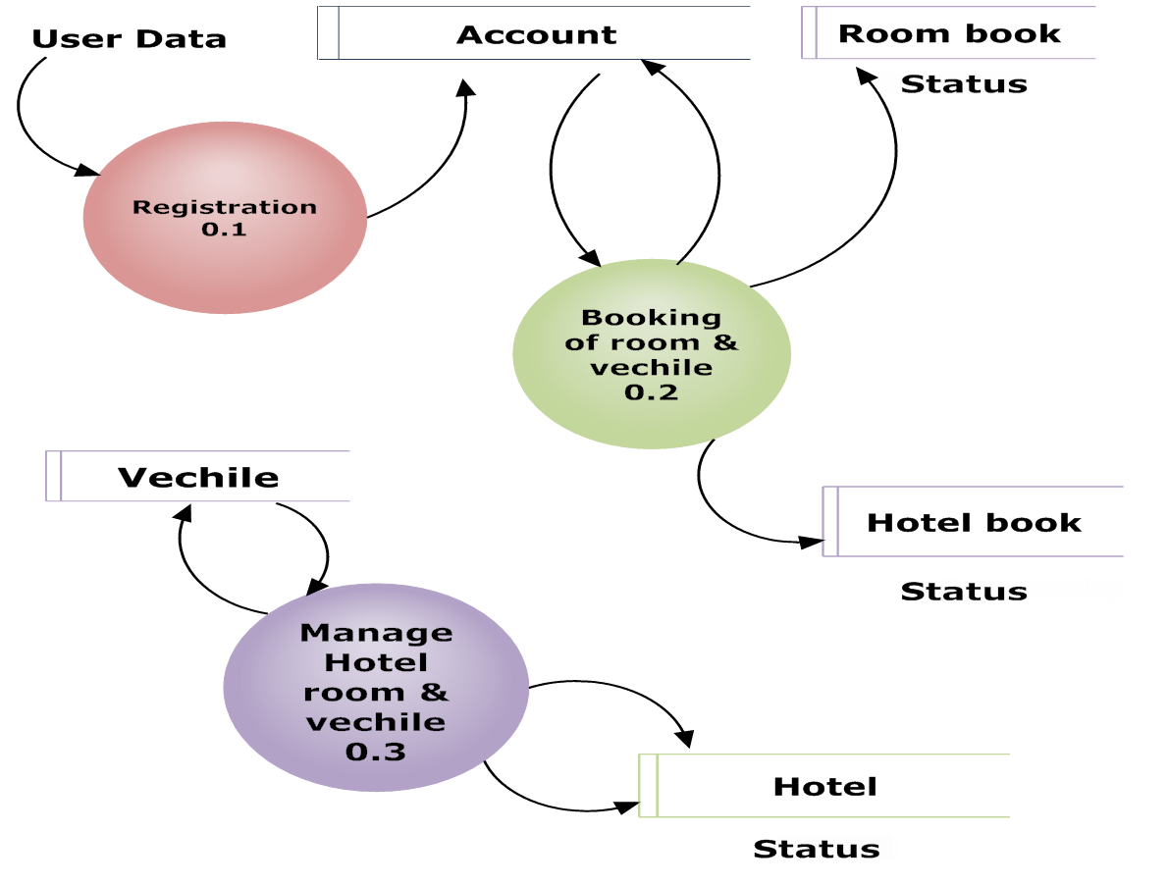

**LEVEL 2 DFD OF REGISTRATION**



**LEVEL 2 DFD FOR BOOKING OF ROOMS & VEHICLE**

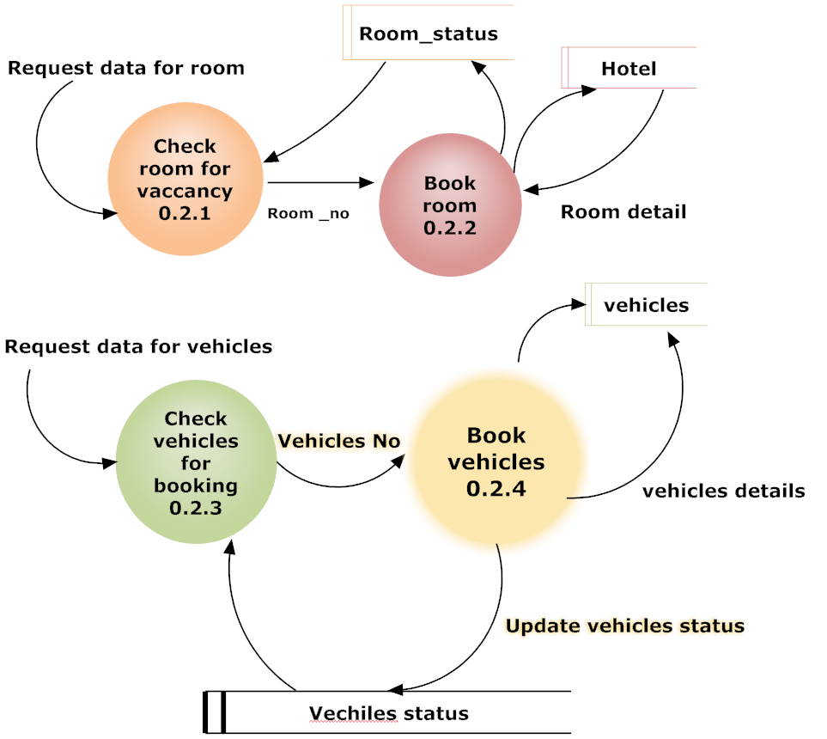

**LEVEL 2 DFD FOR MANAGE HOTEL ROOMS & VEHICLES**

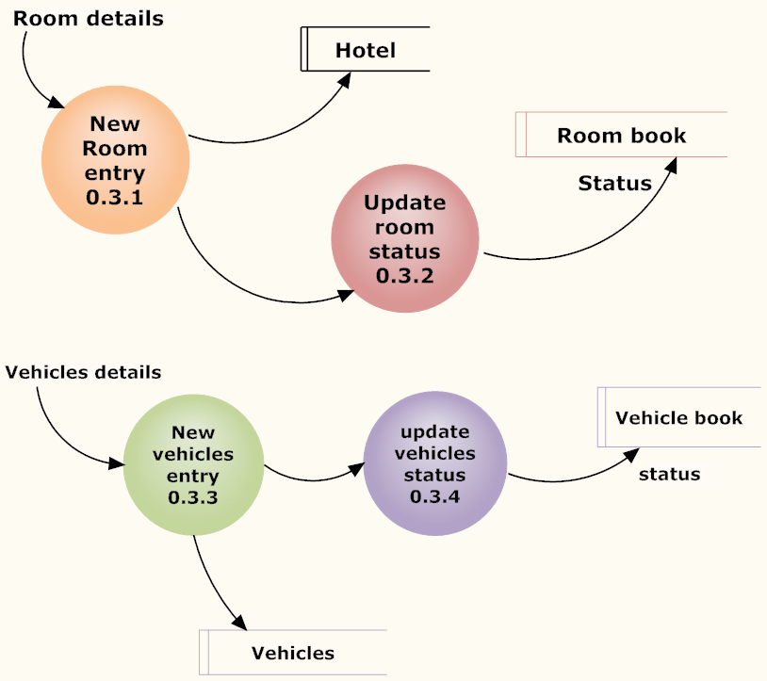

**NORMALIZATION**

Normalization is the process of efficiently organizing data in a database. There are two goals of the normalization process: eliminating redundant data (for example, storing the same data in more than one table and ensuring data dependencies make sense.

Both of these are worthy goals as they reduce the amount of apace a database consumes and ensure that data is logically stored.

**The Normal Forms**

The database community has developed series guidelines for ensuring that database is normalized. These are referred to as normal forms and are numbered from one(the lowest form of normalization ,referred to as first normal form or 1NF) through five (fifth normal form or 5NF)In practical applications, we’ll often see 1NF,2NF and 3NF along with the occasional 4NF.5NF is very rarely seen and won’t be discussed in this article.

Before we begin our discussion of the normal forms, it’s important to point out that they are guidelines and guidelines only.Occasionally,it becomes necessary to stray from them to meet practical business requirements.However,when variations takes place, it’s extremely important to evaluate any possible ramifications they could have on your system and account for possible inconsistencies. That said, let’s explore the normal forms.

**First Normal Form (1NF)**

First Normal Form (1NF) sets the very basic rules for an organized database:

1. Eliminate duplicate columns from the same table.
2. Create separate tables for each group of related data and identify each row with unique column or set of columns (the primary key).

**Second Normal Form (2NF)**

Second Normal Form (2NF) further addressed the concept of removing duplicative data:

1. Meet all the requirements of the first normal form.
2. Remove subsets of data that apply to multiple rows of a table and placed them in separate tables.
3. Create relationship between these new tables and their predecessors through the use of foreign keys.

**Third Normal Form (3NF)**

Third normal form (3NF) goes one large step further:

1. Meet all requirements of the Second normal form.
2. Remove columns that are not dependent upon the primary key.

**Fourth Normal Form (4NF)**

Finally, fourth normal form (4NF) has one additional requirement:

1. Meet all the requirements of the third normal form.
2. A relation is in 4NF if it has no multi-valued dependencies.
3. Remember, these normalization guidelines are cumulative. For a database to be in 2NF, it must first fulfill all the criteria of a 1NF database.

**ENTITY-RELATIONSHIP DIAGRAM**

An entity-relationship (ER) diagram is a specialized graphic that illustrates the interrelationships between entities in a database.

ER diagrams often use symbols to represents three different types of information.

Boxes are commonly used to represent entities. Diamonds are normally used to represent relationship and ovals are used to represent attributes.

It shows the different relationships exist between tables present in the database. The different types of symbols are as follows.

|  |  |
| --- | --- |
| Entity Set |  |
| Relationship Set | Is A  Specialization |
| Primary Key | m 1  Many to one relationship |
| 1 m  One to many relationship | M m  Many to many relationship |

**Primary key**

An entity may be defined as a thing which is recognized as being capable of an independent existence and which can be uniquely identified. An entity is an abstraction from the complexities of some domain. When we speak of an entity we normally speak of some aspect of the real world which can be distinguished from other aspects of the real world.

An entity may be a physical object such as a house or a car, an event such as a house sale or a car service, or a concept such as a customer transactions or order. Although the term entity is the one most commonly used, following when we should really distinguish between an entity and an entity- type. An entity-type is a category. An entity strictly speaking, is an instance of a given entity-type. There is usually many instance of an entity-type. Because the term entity-type is somewhat cumbersome, most people tend to use the term entity as a synonym for this term.

Entities can be thought of as nouns. Examples: a computer, an employee, a song, a mathematical theorem. Entities are represented as rectangles.

A relationship captures how two or more entities are related to one another. Relationships can be thought of as verbs, linking two or more nouns. Examples: an owns relationship between a company and a computer, a supervises relationship between an employee and a department, a performs a relationship between an artist and a song, a proved relationship between a mathematician and a theorem. Relationships are represented as diamonds, connected by lines to each of the entities in the relationship.

The model’s linguistic aspect described above is utilized in the declarative database query language ERROL, which mimics natural language, constructs.

Entities and relationships can both have attributes. Examples: an employee entity might have a Social Security Number (SSN) attribute; the proved relationship may have a data attribute. Attributes are represented as ellipses connected to their owning entity sets by a line.

Every entity (useless it is a weak entity) must have a minimal set of uniquely identifying attributes, which is called the entity’s primary key.

Entity-relationship diagram don’t show single entities or single instances of relations.

Rather they show entity sets and relationship sets. Example: a particular song is an entity. The collection of all songs in a database is an entity set. The eaten relationship between a child and her lunch is a single relationship. The set of all such child-lunch relationship in a database is a relationship set. In other words, a relationship set corresponds to a relation in mathematics, while a relationship corresponds to a member of the relation. Certain cardinality constraints on relationship sets may be indicated as well.

**COURSE OF ACTION AND COMPILATION**

**Title : Hotel Management System.**

**Platform : Windows XP.**

**Language : JSP/servlet.**

**Editor : Adobe Dreamweaver CS4.**

**DATABASE DESIGN**

System design is the solution to the creation of a new system. This phase is composed of several systems. This focuses on the detailed implementation of the feasible system. It emphasis on translating design specification to performance specification. System design has two phases of development logical and physical design.

During local design phase the analyst describes inputs (Sources), outputs (destinations), databases (data source) and producers (data flows) all in a format that meats the uses requirements. The analyst also specifies the user needs and at a level that virtually determines the information flow in to and out of the system and the data resources. Here the logical design is done through data flow diagrams and database design.

The physical design is followed by physical design or coding. Physical design produces the working system by defining the design specifications, which tell the programmer exactly what the candidate system must do. The programmers write the necessary programs that accept input from the user, perform necessary processing on accepted data through call and produce the required report on a hard copy or display it on the screen.

**Decision table………….**

A Decision Table is a table of contingencies for defining a problem and the actions to be taken. It is a single representation of the relationships between conditions and actions.

**Table Name: ACCOUNT**

**Description:**  This table is used tostores the details information of Account.

This table is given below.

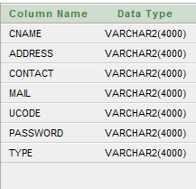

**TABLE NAME: BILL**

**Description:** This table is used to store the details of customer bill.

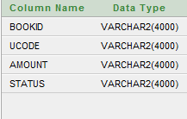

**Table name: BOOKING**

**Description:** This table is used to store the booking of the customer.

The table list is given below

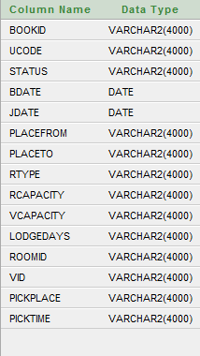

**Table name: HOTEL**

**Description:** This table is used to give the details of the hotel.

The table list is given below:

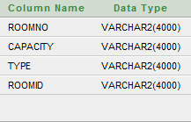

**Table name: BOOK_ROOM_STATUS**

**Description:** This table is used to give the details of the customer room.

The table list is given below:

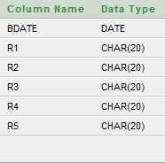

**Table name: VEHICLE**

**Description:** This table contains the details of the vehicle.

The table list is given below:

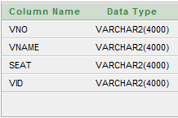

**Table name: VEHICLE_BOOK_STATUS**

**Description:** This table contains the booking status of the vehicle.

The table list is given below:

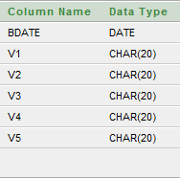

**SYSTEM TESTING**

System testing is a critical aspect of software Quality Assurance and represents the ultimate review of specification, design and coding. Testing is a process of executing a program with the intent of finding an error. A good testing is one that has a probability of finding an as yet undiscovered error. The purpose of testing is to identify and correct bugs in the developed system. Nothing is complete without testing. Testing is the vital to the success of the system.

In the code testing the logic of the developed system is tested. For this every module of the program is executed to find an error. To perform specification test, the examination of the specifications stating what the program should do and how it should perform under various conditions.

Unit testing focuses first on the modules in the proposed system to locate errors. This enables to detect errors in the coding and logic that are contained within that module alone. Those resulting from the interaction between modules are initially avoided. In unit testing step each module has to be checked separately.

System testing does not test the software as a whole, but rather than integration of each module in the system. The primary concern is the compatibility of individual modules. One has to find areas where modules have been designed with different specifications of data lengths, type and data element name.

Testing and validation are the most important steps after the implementation of the developed system. The system testing is performed to ensure that there are no errors in the implemented system. The software must be executed several times in order to find out the errors in the different modules of the system.

Validation refers to the process of using the new software for the developed system in a live environment i.e., new software inside the organization, in order to find out the errors. The validation phase reveals the failures and the bugs in the developed system. It will be come to know about the practical difficulties the system faces when operated in the true environment. By testing the code of the implemented software, the logic of the program can be examined. A specification test is conducted to check whether the specifications stating the program are performing under various conditions. A part from these tests, there are some tests conducted which are given below:

**Peak Load Tests:**

This determines whether the new system will handle the volume of activities when the system is at the peak of its processing demand. The test has revealed that the new software for the agency is capable of handling the demands at the peak time.

**Storage Testing:**

This determines the capacity of the new system to store transaction data on a disk or on other files. The proposed software has the required storage space available, because of the use of a number of hard disks.

**Performance Time Testing:**

This test determines the length of the time used by the system to process transaction data. In this phase the software developed Testing is exercising the software to uncover errors and ensure the system meets defined requirements.

Testing may be done at 4 levels:

1. Unit Level.
2. Module Level.
3. Integration & System
4. Regression.

**Unit Testing:**

A unit corresponds to a screen/form in the package. Unit testing focuses on verification of the corresponding class or screen. This testing includes testing of control paths, interfaces, local data structures, logical decisions, boundary conditions, and error handling. Unit testing may use Test drivers, which are control programs to co-ordinate test case inputs and outputs, and Test stubs, which replace low-level modules. A stub is a dummy subprogram.

**Module Level Testing:**

Module Testing is done using the test cases prepared earlier. Module is defined during the time of design.

**Integration & System Testing:**

Integration testing is used to verify the combining of the software modules. Integration testing addresses the issues associated with the dual problems of verification and program construction. System testing is used to verify, whether the developed system meets the requirements.

**Regression Testing:**

Each modification in software impacts unmodified areas, which results serious injuries to that software. So the process of re-testing for rectification of errors due to modification is known as regression testing.

Installation and Delivery: Installation and Delivery is the process of delivering the developed and tested software to the customer. Refer the support procedures. Acceptance and project closure:

Acceptance is the part of the project by which the customer accepts the product. This will be done as per the project closure, once the customer accepts the project; closure of the project is started. This includes metrics collection, PCD, etc.

**IMPLEMENTATION**

Implementation includes all those activities that take place to convert from the old system to the new. The old system consists of manual operations, which is operated in a very different manner from the proposed new system. A proper implementation is essential to provide a reliable system to meet the requirements of the organizations. An improper installation may affect the success of the computerized system.

**Implementation Methods:**

There are several methods for handling the implementation and the consequent conversion from the old to the new computerized system.

The most secure method for conversion from the old system to the new system is to run the old and new system in parallelism this approach, a person may operate in the manual older processing systems well as start operating the new computerized system. This method offers high security, because even if there is a flaw in the computerized system, we can depend upon the manual system. However, the cost for maintaining two systems in parallel is very high. This overweight’s its benefits.

Another commonly method is a direct cut over from the existing manual system to the computerized system. The change can be within a week or within a day. There are no parallel activities. However; there is no remedy in case of a problem. This strategy requires careful planning.

A working version of the system can also implemented in one part of the organization and the personnel will be piloting the system and changes can be made as and when required. But this method is less preferable due to the loss of entirely of the system.

**Implementation plan:**

The implementation plan includes a description of all the activities that must occur to implement the new system and to put it into operation. It identifies the personnel responsible for the activities and prepares a time chart for implementing the system. The implementation plan consists of the following steps.

1. List all files required for implementation.
2. Identify all data required to build new files during the implementation.
3. List all new documents and procedures that go into the new system.

The implementation plan should anticipate possible problems and must be able to deal with them. The usual problems may be missing documents; mixed data formats between current files, errors in data translation, missing data etc.

**CONCLUSION**

The Project “**HOTEL MANAGEMENT SYSTEM”** has been developed as per the requirement specification.

It has been developed in JSP/Servlet the complete system is thoroughly tested with the availability data and throughput reports which are prepared manually.

The system has been developed with much care that it is free of error and at the same time it is efficient and less time consuming.

The important thing is that the system is robust. Avoid malfunction from outsiders.

It goes through all phases of software development cycle. So product is accurate. Also provision is provided for future developments in the system.

**SCREEN SHOTS**

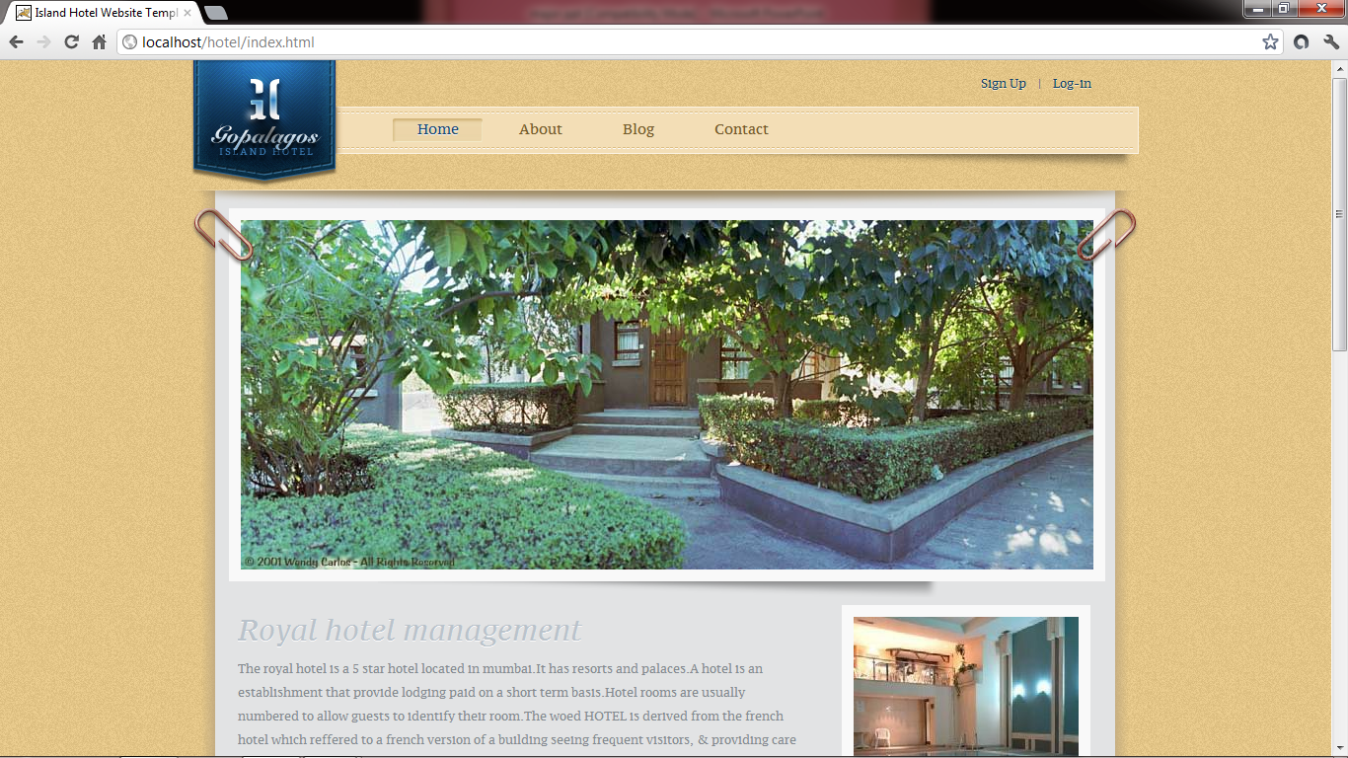

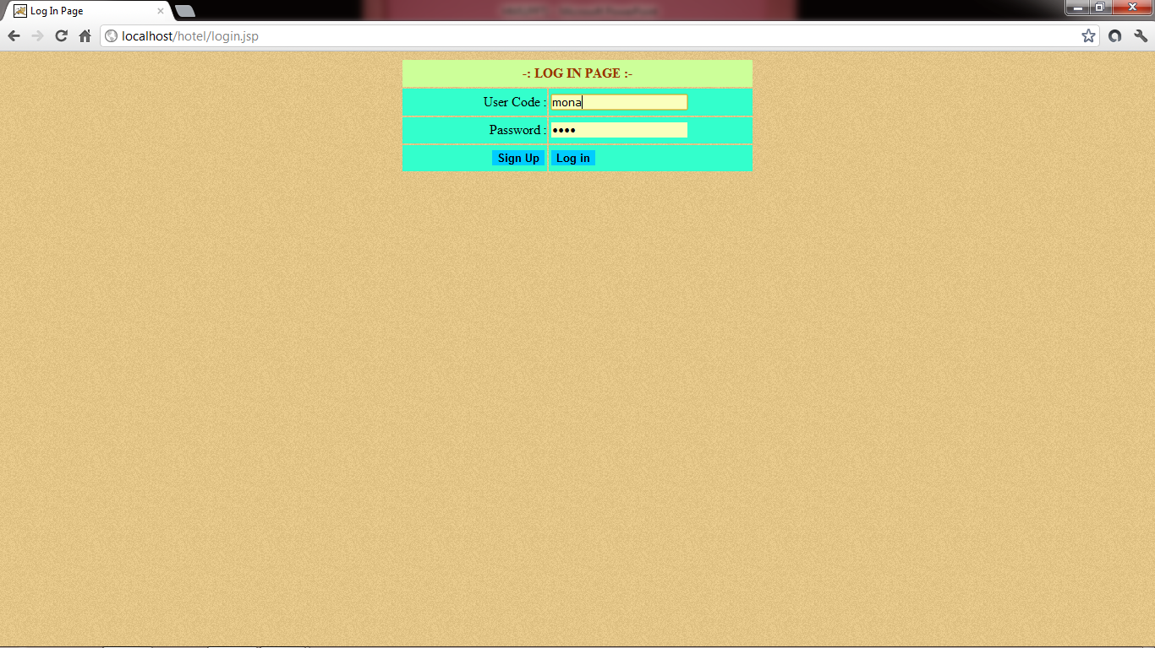

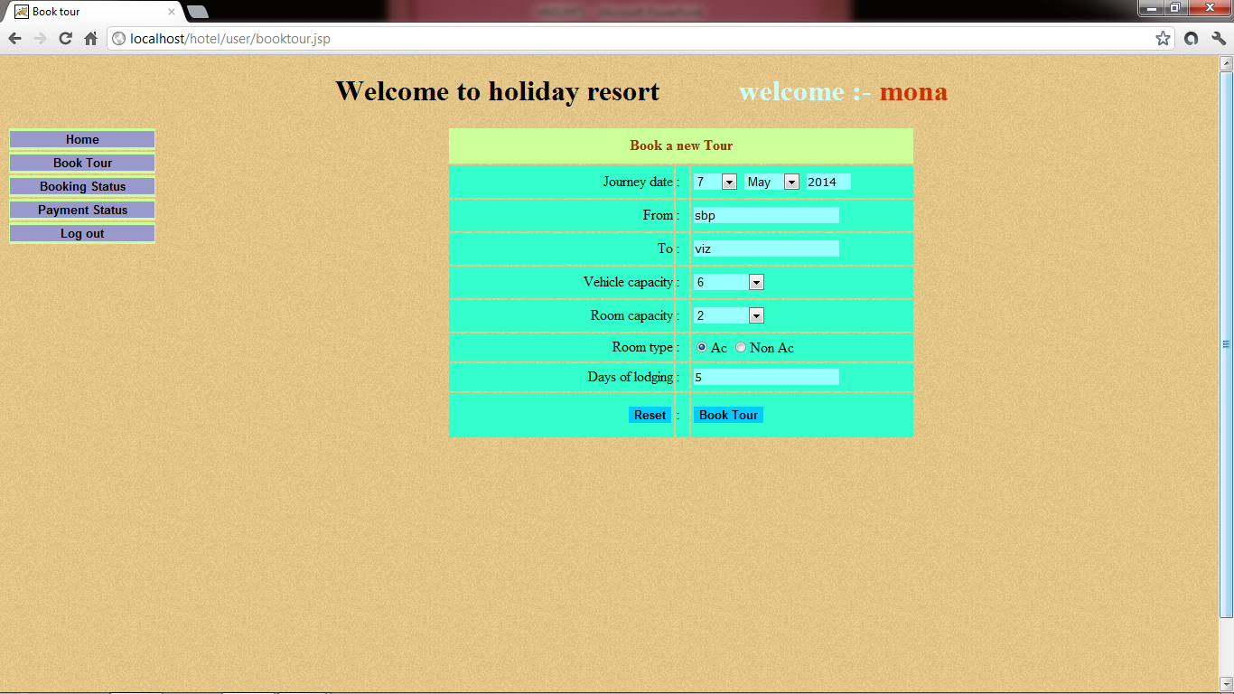

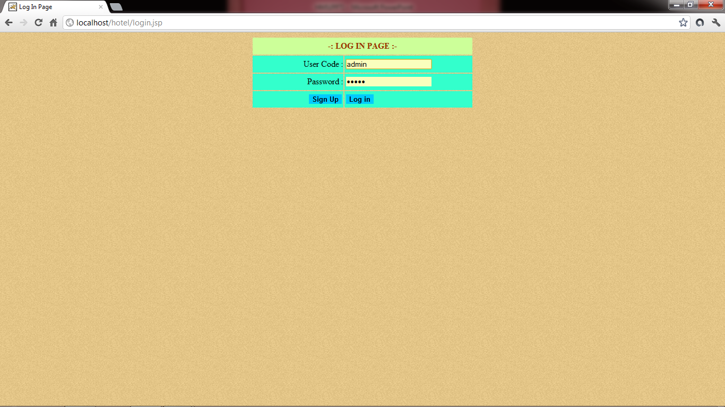

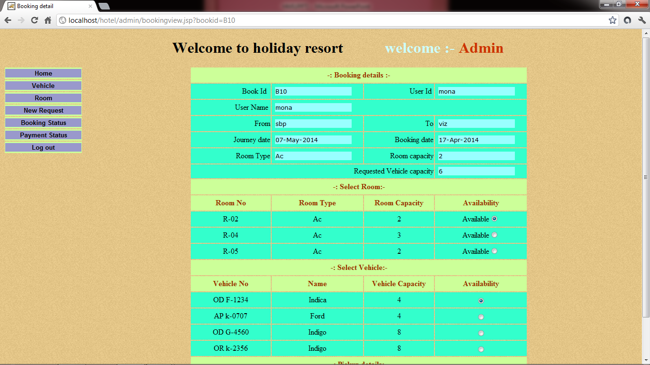

**SCREENSHOT OF DATABASE**

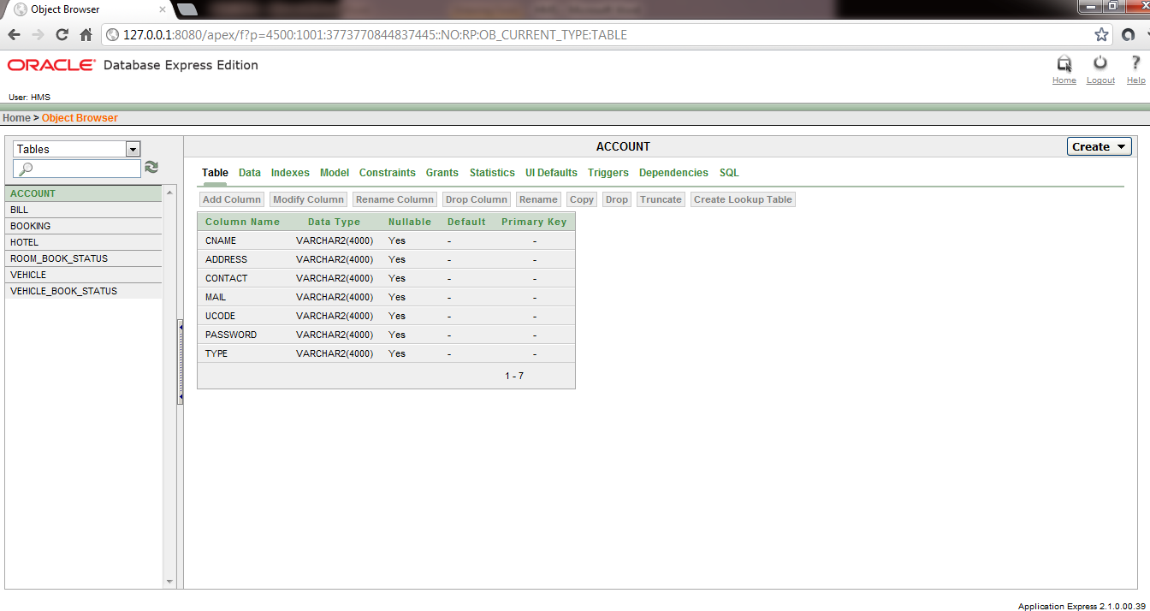

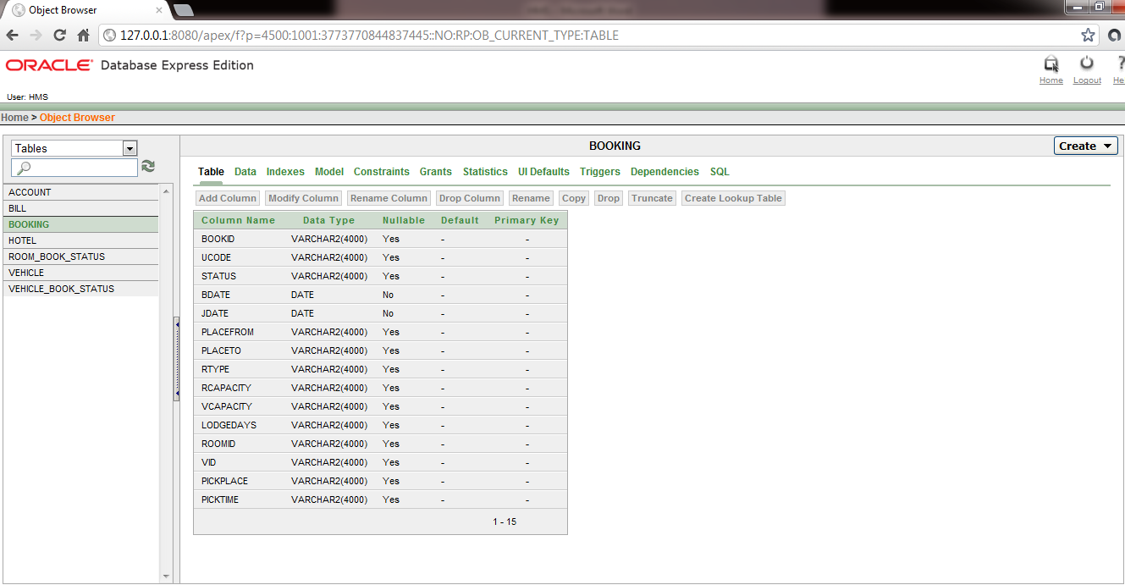

**BIBLIOGRAPHY**

**BOOK AUTHOR NAME**

1. Thinking in java Bruce Eckel

2. Beginning Java 2 Ivor Horton

3. Java Gently Jude Bishop

4. Complete reference java Herbert Scheldt

**WEB REFERENCES:**

[www.en.wikipedia.org/wiki/Java (programming](http://www.en.wikipedia.org/wiki/Java%20%20(programming) language)

www.java.about.com